LISTENER-AI-BASED LIFE ASSISTANCE

CHATBOT INTEGRATION FOR PUBLIC WELFARE

TEAM MEMBERS:

* KUNALI M
* SINDHUJA P
* MUKESH
* KEERTHANA A

INTRODUCTION:

The project is about to create an AI chatbot for mental issue problem people.

Here we gonna reply to any of your questions related to mental issues.

MILESTONE 1:

PROBLEM:

Integrating AI-based chatbots into public welfare programs and services can offer several benefits by improving accessibility, efficiency, and user experience. Here's how such integration can be implemented for various aspects of public welfare:

Information and Assistance:

24/7 Availability AI chatbots can provide round-the-clock access to information and assistance, ensuring that people can get help when they need it.

Information Retrieval:

Users can ask questions about public welfare programs, eligibility criteria, application procedures, and more.

Multilingual Support:

Chatbots can offer support in multiple languages, making information accessible to a diverse population.

Automated Application Process:

Chatbots can guide users through the application process, helping them fill out forms and submit required documents.

SOLUTION:

By doing this AI chatbot, it will be very useful for the mental health affected people, if they want to know about their condition regarding their health, this public welfare chatbot which is mainly created for mental health people.

Defining a problem/statement:

We are defining a problem for people who are struggling due to mental issues,

As we consider that this problem leads to stress, pressured life and finally leads to end the life, so in order to overcome this issue , as a AI learner our team has created a small chatbot for those people , if they want to know about their condition they can access this chatbot anytime.

TOOLS AND TECHNOLOGIES:

* Colab
* NLP,NLTK,Python,IBM Watson assistance , FLASK, artificial Intellegence.

Chatbot flow diagram:

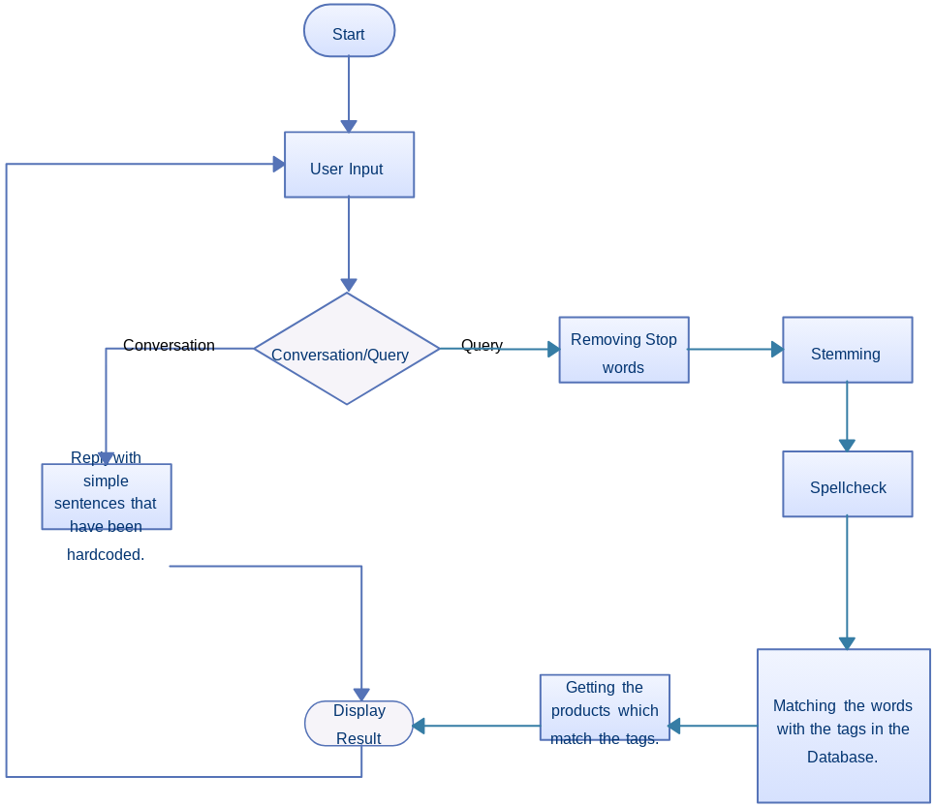

CONCLUSION:

A CBT-based chatbot is a feasible and engaging digital therapeutic approach that allows easy accessibility and self-guided mental health assistance for young adults with depressive symptoms. A systematic evaluation of nonclinical metrics for a mental health chatbot has been established in this study.